DESIGN PATTERNS AND PRINCIPLES
Exercise 2: Implementing the Factory Method Pattern
FactoryMethodPatternExample.java:
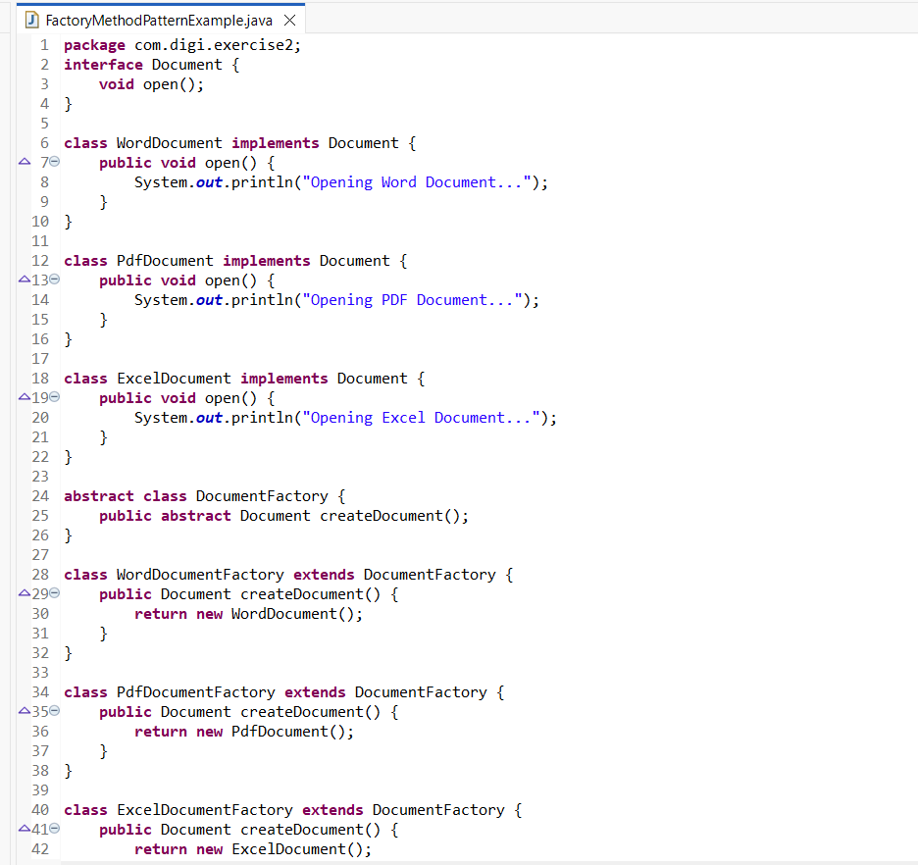
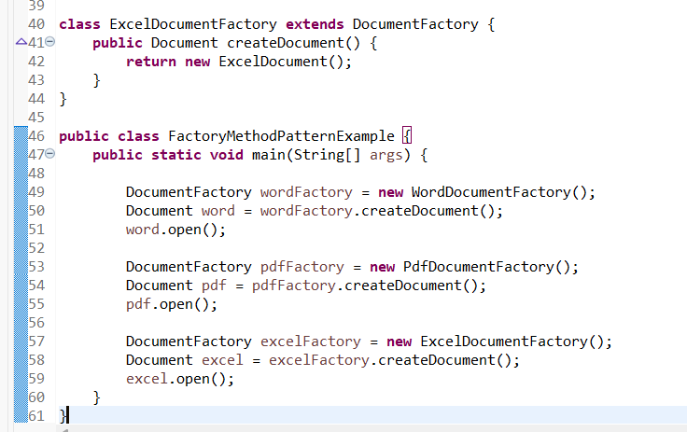

Output:
